Fn

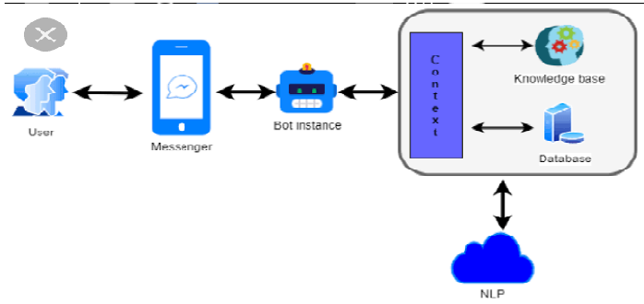

AI CHAT BOT

Table of Contents

1. Introduction 3
2. Statement of the problem 5
3. Objective of the study 6
   1. Specific objectives 6
4. Methodology 6
   1. Study Area 6
   2. Study Period 6
   3. Study Design 7

4.4. Study Variables 8

* 1. The proposed System Model 8
  2. Tools and Materials 9

1. Planning and Time Schedule 9
2. Estimated Research Budget 10

References 11

# Introduction

Technology plays a massive role in the industry and daily chores. It serves a variety of purposes and is applied in a different part of the world. Recently, the public has been fantasized by artificial intelligence simulates the cognitive abilities of a human. To be more precise and closely related to humans, the AI chatbots are know replacing human response with this software.A chatbot is a computerized program that acts like a colloquist b/n the human and the bot, a virtual assistant that has become exceptionally popular in recent year mainly due to dramatic improvements in the area like artificial intelligence, machine learning and other underlying technologies such as neural networks and natural language processing. These chatbots effectively communicate with and human being using interactive queries. Recently, there’s been a massive increasing in many cloud-based chatting bot services which have been made available for the development and improvement of the chatbot sector such as IBM Watson, cleverbot, ELIZA chatbot and many others. These conversational agents have become more responsive and the art of conversation between humans and robots over the pat few years have improved drastically.

In this paper, we have generalized the AI chatbots and described the advanced bots in the market today. They utilize machine learning and artificial intelligence technology like voice recognition, speed -to -text conversion algorithms, etc to interpret the user’s sentiments. The underlying ideology of this type of bot is to figure out what the user’s intentions are and correspondingly present a thoughtful answer by deciphering the pattern in the database. The bot learns and grows over time by encountering many more experiences. A simple example of such a bot can be seen in a food delivery application. Here the previous order history along with the user’s payment options and delivery address are stored on the database. These chatbots analyze the user’s perspective and suggest recommendation based on consecutive orders and user’s likings.

# 2.statement of the problems

Before we start looking at the 3 major problems that chatbots face, let us first establish what a chatbot actually is and how they are being used today. In layman terms, a chatbot is a computer program that can have text or voice based conversations with a human. Recent advancements in naturals language processing have made it possible for chatbots to hold longer, deeper and more natural conversations with humans. Thousands of chatbots already exist on platforms such as Messengers, Telegram, Slack, Kik and Skype.

Chatbots on messenger platforms are still relatively new, and there are still things that are hindering chatbots from reaching mainstream user adoption. Below are 3 major problems with chatbots and chatbot development.

**1.Discovering bots is still an issue for potential users**

Most people using messaging platforms such as facebook messanger are still not aware that chatbots on many messaging platforms is still very limited at the moment. Without massive marketing efforts, it is very difficult for bot developers to get in front of massive audiences on messaging platforms.

**2.No established business models**

A monetization strategy for developers who create chatbots for messenger currently does not exist. In other word, chatbot developers have no way to make money from their chatbot, unless they develop these bots for a third party. That is not to say that one of the major platforms will not deploy a compelling monetization method in the coming years. Perhaps in a few years’ users will have to pay a small fee for premium apps on the app store. Chatbot may not provide direct value to developers, but may be useful for large companies who hope to engage with more users and hence get more sales.

**3.Most chatbots aren’t that great at having normal conversations**

The relatively low barrier to entry for chatbot has been published since messenger had announced that it was allowing chatbots on its messenger platform. This has caused an influx of bots in a relatively short amount of time, with chatbots on these messenger platforms are still relatively new, so as natural language processing technology improve the ability for chatbots to hold longer deeper and more meaningful interactions will also significantly improve with time.

# 3.Objective of the study

The aim of this study is to develop and implement an effective and robust end-to-end ai chatbot and perdition system by collecting dataset which suits the deep learning algorithms to be trained on.

## Specific objectives

Assessment of factors which contribute to ai chatbot at selected target sites

Collection of datasets and exchanging public dataset for deep leaning phyton development for various application or chat bot

Analyzing and processing the collected data

Evaluating and testing the developed model in real time data

# 4.Methodology

In this Section, the materials and methods used to collect the inputs data for the system to be designed, the techniques and methods followed to design the ai chatbot system are clearly described. It also discusses the study area and data collection techniques. The flow chart of the proposed research activities is shown in cover page.

## Study Area

The research will be conducted in Ethiopia. The reason for the choosing this country is that not used ai chat. The study area of this chatbot in medical area, personal communication. We would like to address the community problems which are both at local and national level in this research.

## Study Period

This research will be conducted from march/23/2021 – march/30/2021 including the data collection period and system testing in real-world scenario.

## Study Design

To acquire relevant data for the system to be designed, both primary and secondary sources of data will be used and qualitative as well as quantitative project strategies will be employed. The qualitative project method is used to access of chatbot, economically and psychologically to the residents of the study area. The quantitative data will be collected for input to model, to optimize and test the proposed system.

chatbots

Contextual chatbots

Keyword recognition chatbot

Menu button chatbot

Social messengers

Service action

chatbots

Voice enabled chatbots

Scripted chatbots

Fig.1. The flow chart of the activities of proposed project.

**. Study Variables**

The independent variables in this study consists of time, data of the personal communication and social data of the study area. The dependent variable is the accuracy of the ai chatbot detection system

# 5.Conclusion

A chatbot is an ecosystem, a virtual human being that has been integrated with various industrial application. With the passage of time, new features are added to the existing platforms to create better virtual assistants. Chatbots like have created an impact in the world of technology. Lately, with the concept of artificial intelligence, machine learning, natural processing language and recent advancement in machine learning technique like deep learning, it has been made possible to develop humanoid chatbots.

# 

